EC-390 Digital Signal Processing
BS (CE)-2020
Semester Project Report



Submitted By
Owais Iqbal Malik (20-CE-005)
Zerkaish Saeed (20-CE-012)

Submitted To
Engr. Ali Raza
Dated
14th June, 2023

Department of Computer Engineering
HITEC University Taxila

Abstract:

Convolution and quantization are fundamental techniques used in signal processing for audio and image data. Convolution involves the mathematical operation of combining two signals to produce a third signal, which represents the interaction between the original signals. It is commonly used in tasks such as filtering, feature extraction, and signal analysis. In the context of audio, convolution can be applied to modify the spectral content, simulate reverberation, or implement audio effects. In the case of image processing, convolution is employed for tasks like blurring, sharpening, edge detection, and object recognition.
Quantization, on the other hand, refers to the process of reducing the precision or resolution of a signal. It involves dividing the signal's amplitude range into a finite number of levels or quantization intervals. This technique is essential for digitizing analog signals, where continuous values are approximated by discrete values. Quantization is commonly used in audio and image compression algorithms, where reducing the number of bits required to represent the data leads to reduced storage requirements or transmission bandwidth.
In this abstract, we explore the application of convolution and quantization on audio and image signals. We discuss their underlying principles, techniques, and their respective impacts on the processed data. Additionally, we examine common challenges and considerations associated with these techniques, including trade-offs between computational complexity, signal fidelity, and storage requirements. Understanding convolution and quantization in the context of signal processing provides valuable insights into the manipulation and analysis of audio and image data.

Table of Contents
Abstract: 2
Table of Figures 4
Convolution & Quantization on Signal, Image and audio using MATLAB 5
Introduction: 5
Background: 5
Objectives: 6
Significance: 6
Literature Review: 7
Block Diagram / Flow Chart 7
Methodology: 8
Tools Used: 9
Source Code: 9
1. Signal_conv.m 9
2. Audio_conv.m 10
3. Image_conv.m 11
4. Signal_quant.m 12
5. Audio_quant.m 13
6. Image_quant.m 14
7. Mainfile.m 14
Results: 16
Benefits / Drawbacks 20
Convolution 20
Quantization 20
Conclusion: 20
References: 21

Table of Figures
Figure 1: Block Diagram 7
Figure 2: General Working 8
Figure 3: Quantization Block Diagram 8
Figure 4: Flow Chart 9
Figure 5: Output of convolution 16
Figure 6: Signal Convolution 17
Figure 7: Audio Convolution 17
Figure 8: Convolution Output 18
Figure 9: Convolution on Image 18
Figure 10: Quantization on Signal 19
Figure 11: Audio Quantization 19
Figure 12: Image Quantization 20
Figure 13: Image Quantization Result 20

Convolution & Quantization on Signal, Image and audio using MATLAB

Introduction:
Signal processing techniques play a crucial role in analyzing, manipulating, and representing audio and image data. Among these techniques, convolution and quantization are fundamental operations that are widely used in various applications. Convolution allows us to understand the interaction between signals, while quantization enables the digitization and compression of analog signals.
Convolution involves the mathematical operation of combining two signals, often referred to as the input signal and the impulse response, to produce a third signal known as the output signal. It is a fundamental operation in the field of signal processing and is extensively utilized in audio and image analysis. By convolving an input signal with an appropriate filter, one can extract specific features, modify the spectral content, or simulate the behavior of real-world systems. In the context of audio, convolution is employed for tasks such as noise reduction, equalization, and audio effects. In image processing, convolution is used for operations like blurring, sharpening, edge detection, and pattern recognition.
Quantization, on the other hand, is the process of approximating continuous signals with a limited number of discrete values. This operation is essential for converting analog signals into digital form, where they can be stored, processed, and transmitted. Quantization involves dividing the amplitude range of a signal into a finite number of levels or quantization intervals. By reducing the resolution or precision of the signal, quantization allows for efficient representation and compression of data. In audio applications, quantization is applied during analog-to-digital conversion, audio compression algorithms (such as MP3), and various audio effects. In image processing, quantization is used for color space conversion, image compression (such as JPEG), and reducing the bit depth for storage or transmission purposes.

Background:
Convolution and quantization are fundamental techniques in signal processing that have significant applications in audio and image processing.
Convolution is a mathematical operation that combines two signals to produce a third signal, representing the interaction between the original signals. It is widely used in tasks such as filtering, feature extraction, and signal analysis. In audio processing, convolution is applied to modify the spectral content, simulate reverberation, or implement audio effects. In image processing, convolution is used for operations like blurring, sharpening, edge detection, and object recognition.
Quantization, on the other hand, involves reducing the precision or resolution of a signal. It is crucial for digitizing analog signals, where continuous values are approximated by discrete values. Quantization is commonly used in audio and image compression algorithms to reduce storage requirements or transmission bandwidth. In audio processing, quantization is applied during analog-to-digital conversion and audio compression algorithms. In image processing, quantization is used for color space conversion, image compression, and reducing bit depth for storage or transmission.
Understanding convolution and quantization provides valuable insights into the manipulation and analysis of audio and image data, enabling professionals to develop advanced algorithms and systems in these domains.

Objectives:
Following are the main objectives of our project:
- Understand how Convolution process combines the two signals to form a new signal.
- Understand how Quantization process maps all inputs within a specified range.
- Implementation of Convolution and Quantization using MATLAB.
- Implementation of Convolution and Quantization for Sound and Image Processing.

Significance:
Convolution and quantization are both significant techniques in signal processing with profound implications for audio and image data. Understanding their significance helps us appreciate their contributions to various applications and fields. Here are some key points highlighting their significance:
- Analysis and Manipulation: Convolution enables us to analyze the interaction between signals, extract features, and modify the spectral content. It plays a critical role in tasks such as filtering, equalization, noise reduction, and audio effects in audio processing. In image processing, convolution allows for operations like blurring, sharpening, edge detection, and pattern recognition. These operations are essential for tasks ranging from audio enhancement and restoration to image enhancement and computer vision.
- Realistic Simulation: Convolution is instrumental in simulating real-world effects and environments. In audio processing, it helps simulate reverberation, spatial acoustics, and various audio effects, contributing to realistic sound production in music, film, and virtual reality applications. In image processing, convolution allows for simulating blurring or degradation effects caused by motion or optics, aiding in realistic image rendering and simulation.
- Feature Extraction and Recognition: Convolution plays a key role in feature extraction for both audio and image data. By convolving signals with appropriate filters or kernels, specific features can be enhanced or isolated. In audio processing, this facilitates tasks such as speech recognition, music genre classification, and sound event detection. In image processing, convolution is crucial for tasks like object recognition, texture analysis, and edge detection.
- Efficient Representation and Compression: Quantization is vital for representing and compressing audio and image data efficiently. By reducing the precision or bit depth of signals, quantization enables the storage and transmission of data in a more compact form. In audio compression algorithms like MP3, quantization reduces the number of bits required to represent audio data, resulting in smaller file sizes without significant perceptual loss. In image compression algorithms like JPEG, quantization reduces the precision of color and intensity values, leading to reduced file sizes while maintaining acceptable visual quality.
- Digital Signal Processing: Convolution and quantization are foundational techniques in digital signal processing (DSP), a field crucial for numerous applications. DSP enables advanced audio and image processing algorithms, including speech recognition, audio and image compression, medical imaging, video processing, and more. Understanding convolution and quantization is essential for effectively implementing and optimizing DSP algorithms and systems.

Literature Review:
We have studied and implemented the following concepts for the development of our project:
Convolution is a simple mathematical operation which is fundamental to many common image processing operators. Convolution provides a way of multiplying together two arrays of numbers, generally of different sizes, but of the same dimensionality, to produce a third array of numbers of the same dimensionality.
This can be used in image processing to implement operators whose output pixel values are simple linear combinations of certain input pixel values.
In simple, we need a convolution for combining two signals to form a third new signal.
Quantization, in mathematics and digital signal processing, is the process of mapping input values from a large set (often a continuous set) to output values in a (countable) smaller set, often with a finite number of elements.
- Perform a Convolution process on different signals such as discrete, continuous, sound, and image.
- Perform a Quantization process on different signals such as discrete, continuous, sound, and image.

Block Diagram / Flow Chart
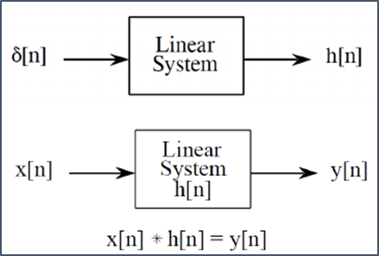
Figure 1: Block Diagram
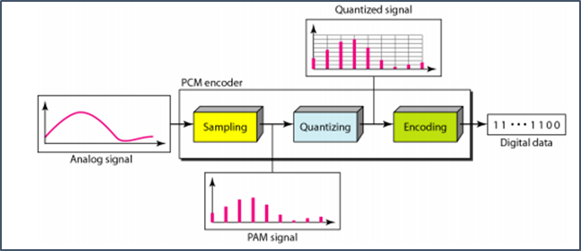
Figure 2: General Working
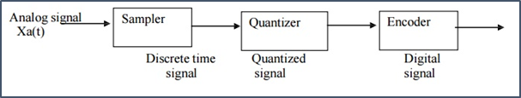
Figure 3: Quantization Block Diagram

Methodology:
We used a Waterfall Methodology to create this project.
Requirements: Convolution and Quantization on Discrete and Continuous Signals, for Sound Processing, and Image Processing.
Design: A higher level or logical design is created that describes the purpose and scope of the project, flow of each component and the integration points.
Implementation: We used MATLAB Scripts for all the requirements.
Verification / Testing: We performed all the tests on this project and all the tests passed successfully.
Maintenance: If errors are found and change requests come in from users, we will update the project and release a new version.

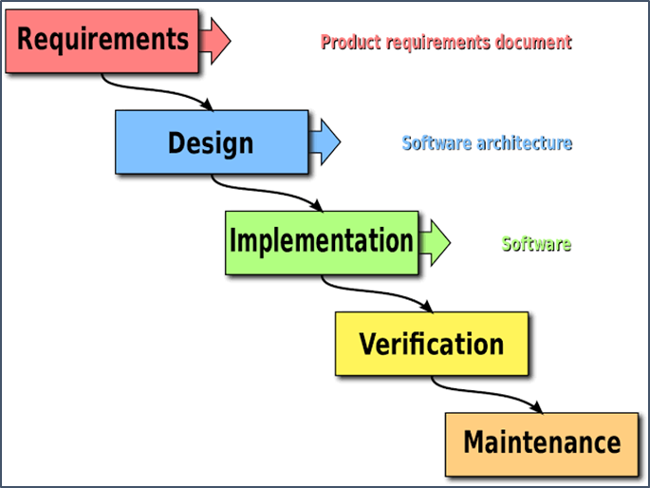
Figure 4: Flow Chart

Tools Used:
- MATLAB Scripts.

Source Code:

Signal_conv.m
function signal_conv()
% Initialization
t = -400:400; % Time range
X = zeros(1,length(t)); % Input Signal 1
x1 = -150; x2 = 150; % Range of Input Signal 1
H = zeros(1,length(t)); % Input Signal 2
h1 = -50; h2 = 50; % Range of Input Signal 2
Y = zeros(1,length(t)); xh1 = x1+h1; xh2 = x2+h2; % Convolution output

% Input Signal Generation
%x = sin(pi*t/10)./(pi*t/10); x(t==0)=1; % Generate Input Signal 1
%h = t./t; h(t==0)=1; % Generate Input Signal 2
x=sin(t./10);
h=cos(t./5);
H(t>=h1 & t<=h2) = h(t>=h1 & t<=h2); % Fit the input signal 1 within range
X(t>=x1&t<=x2) = x(t>=x1&t<=x2); % Fit the input signal 2 within range

% Plot Input Signal 1 and Input Signal 2
subplot(3,2,1)
plot(t,X,'b','LineWidth',3)
title('Input Signal 1','FontWeight','b','FontSize',15)
grid on
subplot(3,2,2)
plot(t,H,'r','LineWidth',3)
title('Input Signal 2','FontWeight','b','FontSize',15)
grid on

for n = xh1:xh2 % Convolution limits
% Convolution steps
f = fliplr(X); % Flip
Xm = circshift(f,[0,n]); % Shift
m = Xm.*H; % Multiply
Y(t==n) = sum(m); % Sum

% Live Convolution Process
subplot(3,2,[3 4])
plot(t,H,'r',t,circshift(fliplr(X),[0,n]),'b','LineWidth',3)
title('Convolution Process: 1. Flip, 2. Shift, 3. Multiply 4. Sum','FontWeight','b','FontSize',15)
grid on;

% Result of convolution live
subplot(3,2,[5 6]);
plot(t,Y,'k','LineWidth',3)
axis tight
grid on
title('Convolution Output','FontWeight','b','FontSize',15)
pause(0.01); % Pause between Update
title('Illustration of 1D Convolution','FontWeight','b','FontSize',20)
fig=gcf;
fig.Units='normalized';
fig.OuterPosition=[0 0 1 1]; %Open Current Figure in Maximized Mode
end
end

Audio_conv.m
function audio_conv()
fs=44000;
[y, fs]=audioread('hello.mp3');
info=audioinfo('hello.mp3');
s=y(:, 1);
sound(y, fs);

subplot(3, 1, 1)
plot(y);
title('Audio Signal');

%d=10000;
ylen=length(y);
t=zeros(ylen, 1);
t(1)=4.6;
t(10000)=3.6;
t(20000)=2.6;
t(30000)=1.6;
t(40000)=0.6;

subplot(3, 1, 2)
plot(t, 'r', 'linewidth', 1.5);
title('Impulse Signal');

c=conv(s, t);
subplot(3, 1, 3);
plot(c);
title('Convolved Signal');

pause(2.0375)
sound(c, fs);

end

Image_conv.m
function image_conv()
rgb_image=imread('bike.png');
gray_image=rgb2gray(rgb_image);
a1=double(gray_image);
gaussian=fspecial('gaussian', [5, 5], 2);
motion=fspecial('motion', 10, 45);

conv_gaussian=conv2(gaussian, a1);
conv_motion=imfilter(a1, motion, 'replicate');
self_conv=conv2(a1, a1);

subplot(2, 2, 1)
imshow(gray_image);
title('Original Image');
impixelinfo;

subplot(2, 2, 2)
imshow(conv_gaussian, []);
title('Convolution with Gaussian Filter');
impixelinfo;

subplot(2, 2, 3)
imshow(conv_motion, []);
title('Convolution with Motion Filter');
impixelinfo;

subplot(2, 2, 4)
imshow(self_conv, []);
title('Self Convolution');
impixelinfo;

end

Signal_quant.m
function signal_quant()
t=-400:400;
%y=sin(pi*t/10)./(pi*t/10);
y=sin(t./50);

subplot(3, 1, 1)
plot(t, y); grid on;
title('Original Signal');

n=3;
L=2^n;
fmax=max(max(y));
fmin=min(min(y));
stepsize=(fmax-fmin)/L;

subplot(3,1,2)
z=quant(y, stepsize);
plot(t, z); grid on; hold on;
title('Quantized Signal');

zmin=min(z);
zmax=max(z);

quant_levels=zeros(1, L);
quant_levels(1)=zmin;

for n=2:L
quant_levels(n) = quant_levels(n-1) + stepsize;
if(quant_levels(n)==0)
quant_levels(n)=stepsize;
end
end
quant_levels;

subplot(3, 1, 3)
stem(quant_levels, 'r', 'fill', 'linewidth', 2); grid on;
title('Quantization Levels');

end

Audio_quant.m
function audio_quant()
fs=44000;
[y, fs]=audioread('hello.mp3');
info=audioinfo('hello.mp3');
sound(y, fs);

subplot(3, 1, 1)
plot(y); grid on;
title('Audio Signal Spectrum (Original)');

n=4;
L=2^n;
fmax=max(max(y));
fmin=min(min(y));
stepsize=(fmax-fmin)/L;

subplot(3,1,2)
z=quant(y, stepsize);
plot(z); grid on;
title('Quantized Signal');

zmin=min(min(z));
zmax=max(max(z));

quant_levels=zeros(1, L);
quant_levels(1)=zmin;

for n=2:L
quant_levels(n) = quant_levels(n-1) + stepsize;
if(quant_levels(n)==0)
quant_levels(n)=stepsize;
end
end
quant_levels;

subplot(3, 1, 3)
stem(quant_levels, 'r', 'fill', 'linewidth', 2); grid on;
title('Quantization Levels');

pause(2.0375);
sound(z, fs);

end

Image_quant.m
function image_quant()
rgb_image=imread('bike.png');
gray_image=rgb2gray(rgb_image);

subplot(1,2,1)
imshow(gray_image);
title('Original Image');
impixelinfo;

n=2;
L=2^n;
fmax=max(max(gray_image));
fmin=min(min(gray_image));
stepsize=(fmax-fmin)/L;

subplot(1,2,2)
z=quant(gray_image, stepsize);
imshow(z);
title('Quantized Image');
impixelinfo;

zmin=min(min(z));
zmax=max(max(z))
quant_levels=zeros(1, L);
quant_levels(1)=zmin;

for n=2:L
quant_levels(n) = quant_levels(n-1) + stepsize;
if(quant_levels(n)==0)
quant_levels(n)=stepsize;
end
end

quant_levels;

figure
stem(quant_levels, 'r', 'fill', 'linewidth', 2); grid on;
title('Quantization Levels');

end

Mainfile.m
clc
close all
clear variables

disp('DSP PROJECT');
disp('Convolution & Quantization');

%displaying the menu
disp('*****************************************');

disp('Menu:');
disp('1) Convolution');
disp('2) Quantization');

disp('*****************************************');

%Enter Choice.
choice=input('Enter Your Choice: ');

if(choice==1)

%displaying the convolution submenu
disp('*****************************************');

disp('Convolution SubMenu:');
disp('1) Signal Convolution');
disp('2) Audio Convolution (Echo)');
disp('3) Image Convolution (Blur)');

disp('*****************************************');

choice1=input('Enter Your Choice: ');

if(choice1==1)
signal_conv();
elseif(choice1==2)
audio_conv();
elseif(choice1==3)
image_conv();
else
disp('Invalid Choice.');

end

elseif(choice==2)

%displaying the Quantization submenu
disp('*****************************************');

disp('Quantization SubMenu:');
disp('1) Signal Quantization');
disp('2) Audio Quantization');
disp('3) Image Quantization');

disp('*****************************************');

choice1=input('Enter Your Choice: ');

if(choice1==1)
signal_quant();
elseif(choice1==2)
audio_quant();
elseif(choice1==3)
image_quant();
else
disp('Invalid Choice.');

end

else
disp('Invalid Choice.');

end

Results:

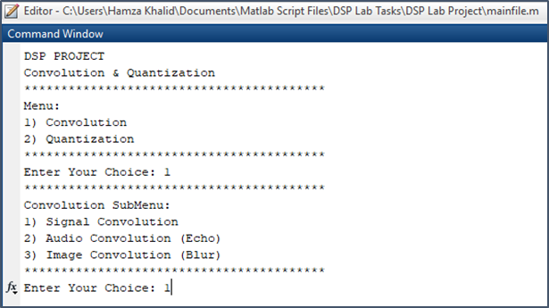
Figure 5: Output of convolution

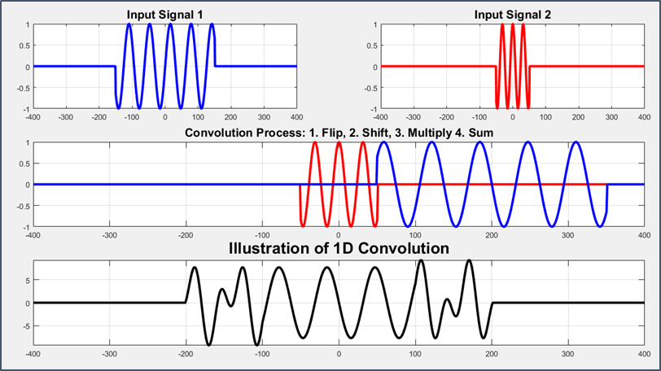
Figure 6: Signal Convolution

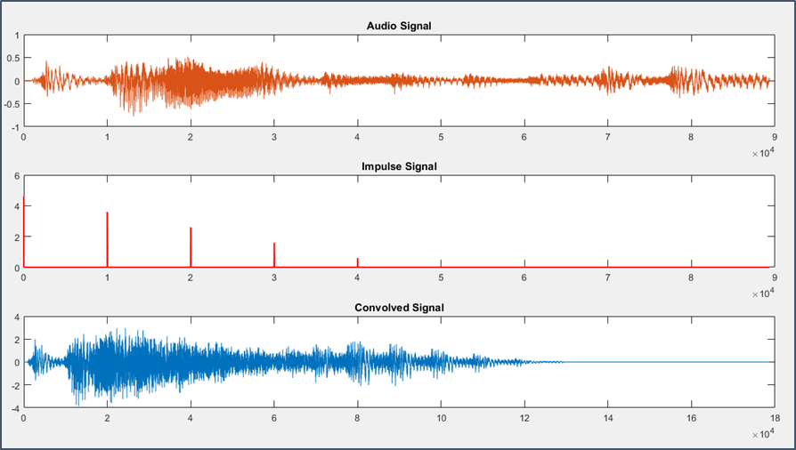
Figure 7: Audio Convolution

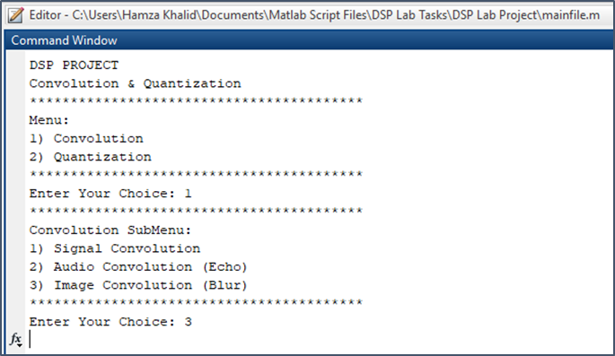
Figure 8: Convolution Output
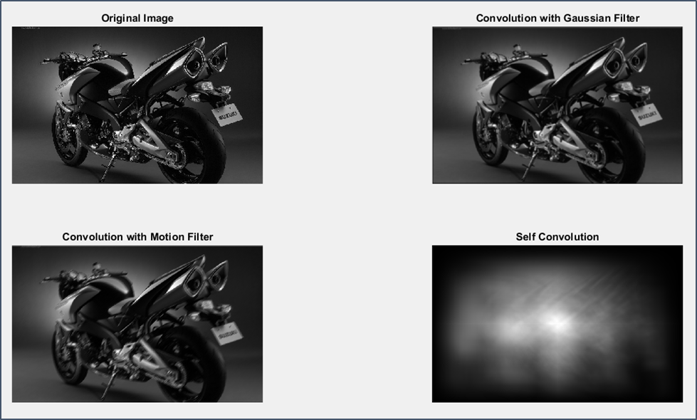
Figure 9: Convolution on Image

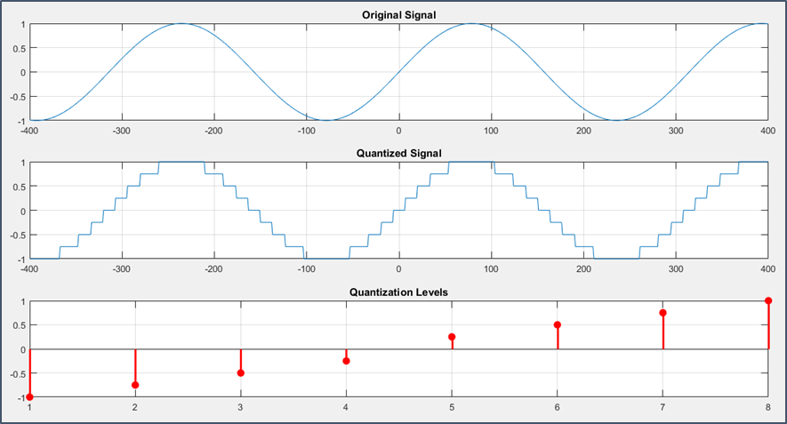
Figure 10: Quantization on Signal

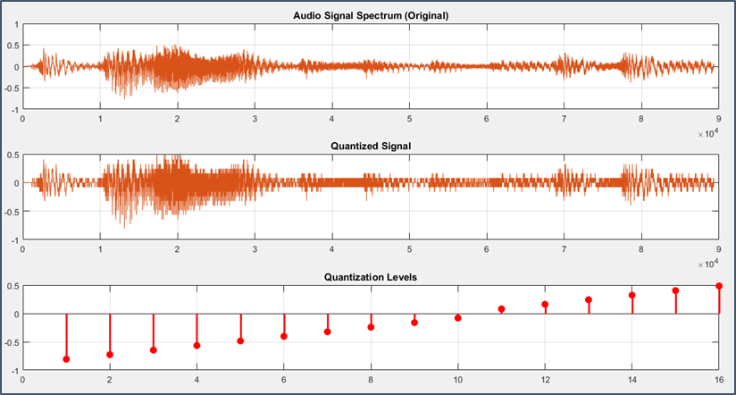
Figure 11: Audio Quantization

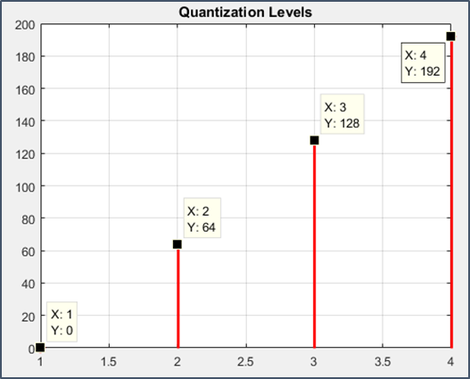
Figure 12: Image Quantization
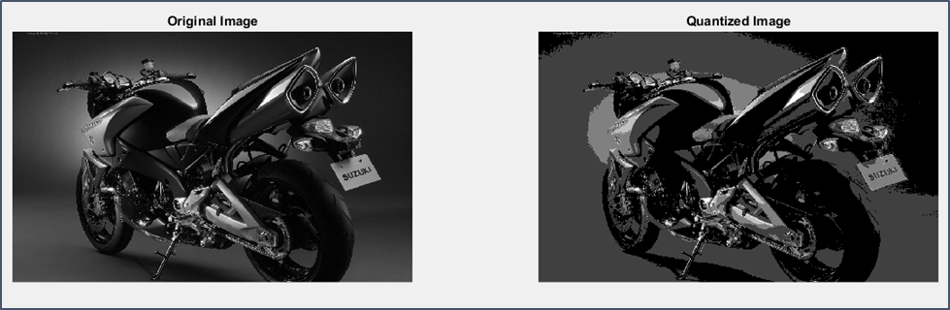
Figure 13: Image Quantization Result

Benefits / Drawbacks

Convolution
By using Convolution, we can perform image processing like sharpening or blur the image, and sound processing like creating a echo in sound signals.
The drawback of Convolution is that it cannot accurately represent how a signal is processed by a nonlinear or time-variant system. So, it really all comes down to determining whether or not acoustic and analog systems are linear, time-invariant (LTI) systems.

Quantization
By using Quantization, we can map all the inputs of continuous signal within a specified range. We also use Quantization for image processing and sound processing.
The drawback of Quantization is that the significant accuracy loss in some models.

Conclusion:
The noise increases in audio when Quantization levels decrease and decreases when the no. of levels increases.
Convolution is a mathematical way of combining two signals to form a third signal. It is a mathematical operation that expresses a relationship between an input signal, the output signal, and the impulse response of a linear-time invariant system.

References:
[1] https://www.tutorialspoint.com/dip/concept_of_quantization.htm
[2] https://www.dspguide.com/ch24/7.htm
[3] https://medium.com/@bdhuma/6-basic-things-to-know-about-convolution-daef5e1bc411#:~:text=In%20image%20processing%2C%20convolution%20is,effect%20of%20the%20convolution%20process.

